002 Data Files and Variables

Revision History:
Version | Change Date | Author | Description of Change
0.001 | 03-19-2014 | Sekhar Arikatla | Created

Data Files
In Dialogue, data files are objects that tell the Engine where to go to read or write data and how to process that information. Dialogue data files do not contain or provide data; they are used to point to an external data source. Data files are found under the Data files heading in the library.

Data File Types and Order
After we create a data file, we define it in the Property Panel and map variables to it, we assign it to one or more applications in the Library. During a production run, the Engine processes the data files in the order they are placed in the application. The standard order of data files in an application is given below:

- Initialization File.
- Customer driver file (in the order they need to be accessed).
- Reference files (in the order they need to be accessed).
- Auxiliary layout files.
- Report files (must be last).

Customer driver File
A Customer driver file object contains one set of records for each customer, which drives
the production process. Customer driver file objects are the only required data file objects in an application. If an application has multiple Customer driver files, the Engine processes them in the order they appear under the application in the Library.

A customer driver file can have different file formats as given below
- Columnar data file
- Delimited data file
- XML data file
- PDF Form
- Live

Create a Columnar data file
In Columnar data file data appears in columns.
1. Right-click a Datafile heading and select new datafile.
New datafile dialog box opens.
2. Give the data file a Name and optionally Description.
3. Select Customer driver file from the File type drop-down list.
4. Select Columnar data file from the File format drop-down list.
5. Click Finish

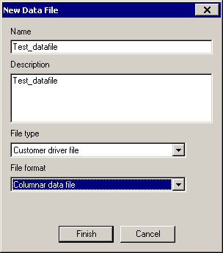

Basic Tab:

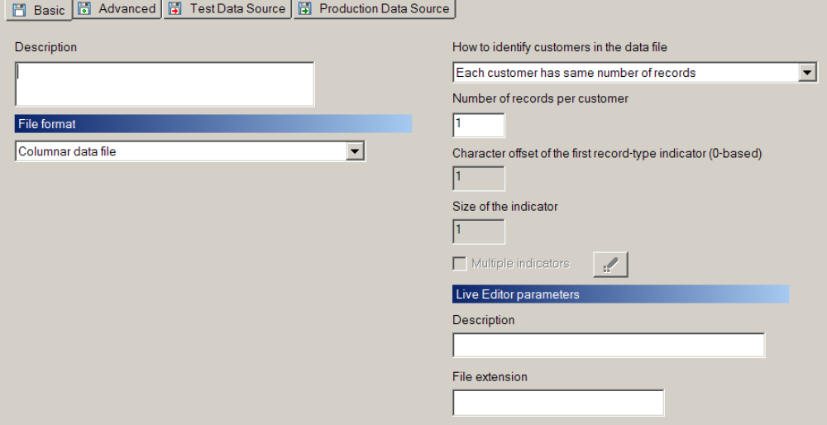

How to identify customers in the datafile:
By default we have Each customer has same number of records property and
Dialogue engine will consider each line as new customer and generates the output for each customer

Test Data Source:

Give the location of the test data source for mapping as shown below

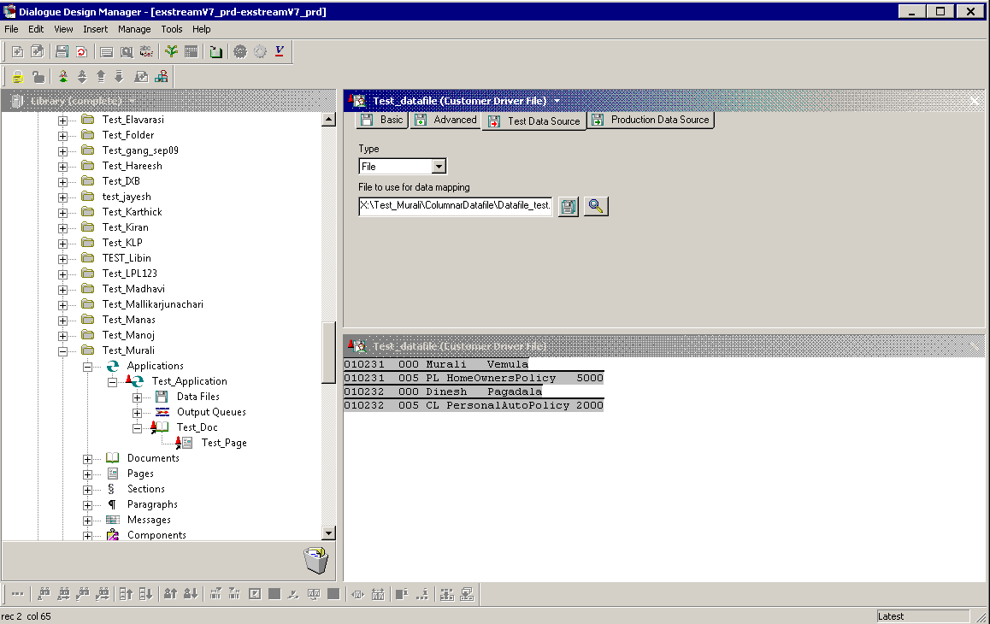

In the above test data each line is considered as new customer.
If the data file contains more than one line for each customer, we have to define a record type
Select A new customer occurs on Specified record types in How to identify customers in the datafile drop down in Basic tab and give the record type position as shown.
In the below example Dialogue engine will consider a new customer whenever it gets “000” record type

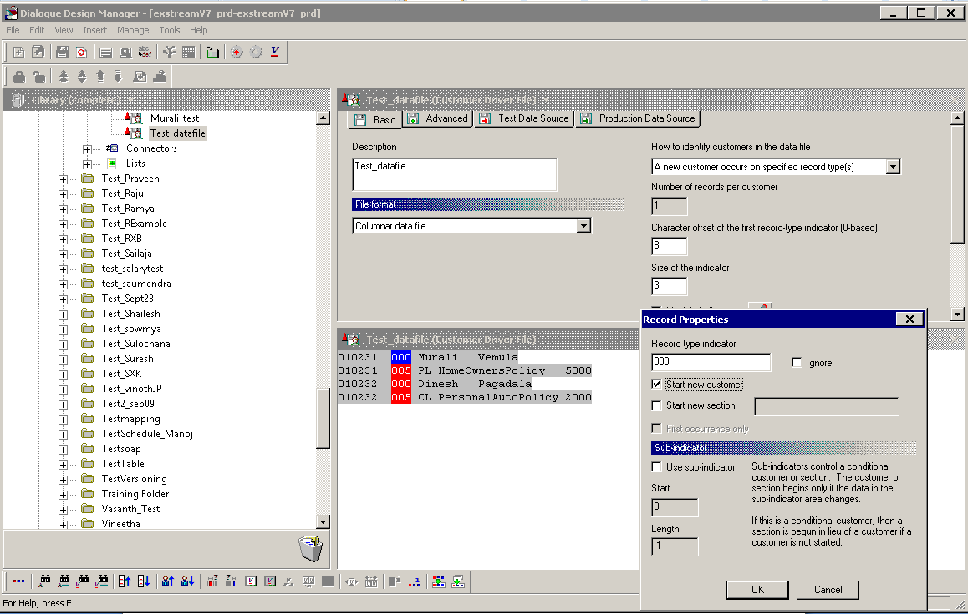

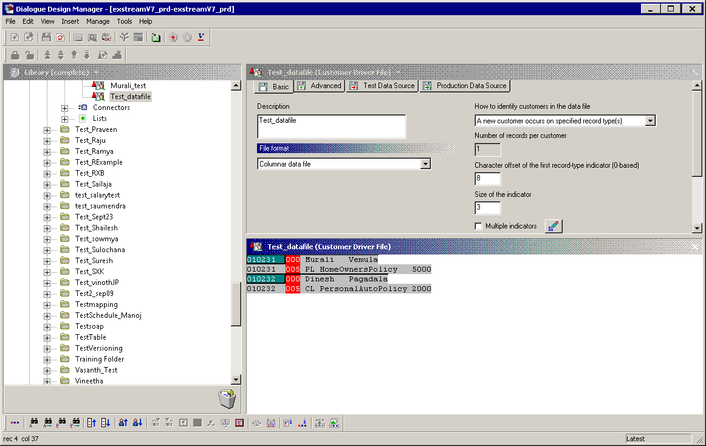

Create a XML data file
In XML data file data appears in XML format. data will be separated by XML tags
1. Right-click a Datafile heading and select new datafile.
New datafile dialog box opens.
2. Give the data file a Name and optionally Description.
3. Select Customer driver file from the File type drop-down list.
4. Select XML data file from the File format drop-down list.
5. Click Finish

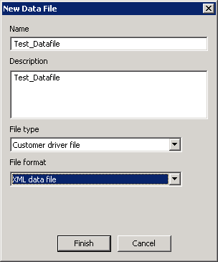

Give the data mapping source in Basic tab, test data source name and also production data source name.
- Open the data file in Edit panel for data mapping.

For XML file, first we need to define the start tag, then only Dialogue engine recognizes that as start point of input file and it will read the input data.

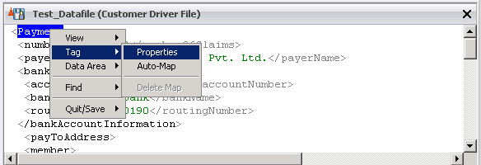

A new window will be opened as shown below.
Go to Options tab -> under start customer drop down select “At start of tag”

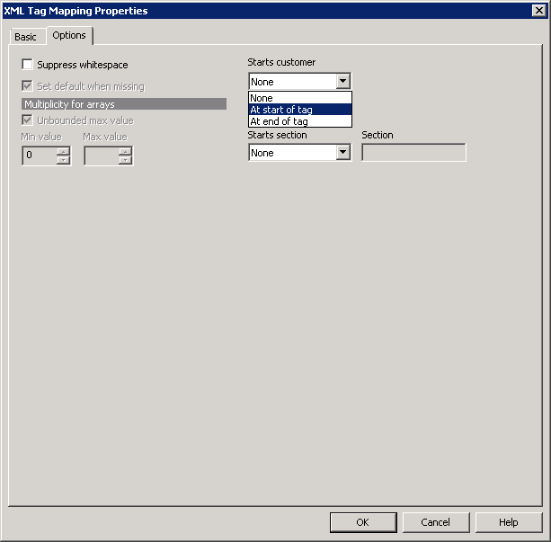

Once we define start tag, we can proceed with the other fields mapping.

Right click on the required tag value select Data Area
->Map Existing Data Tem –If the variable is already created.
-> Map New Data Teem – If the variable doesn’t exists.

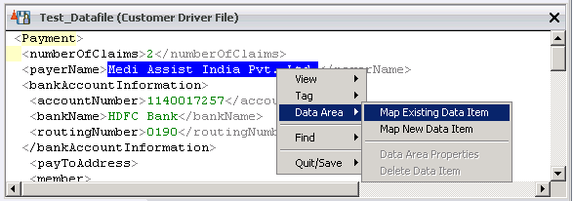

Once we map Data to the variable, data appears in Green color.
If same data is mapped to more than one variable, it appears in blue color

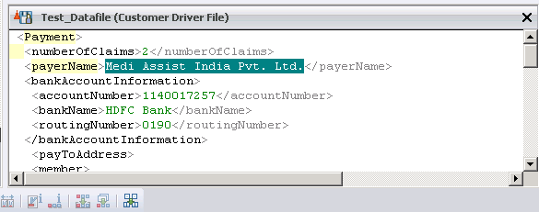

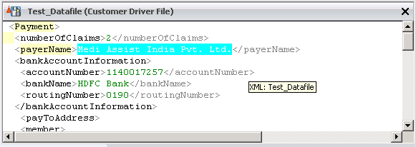

Create a Report file
A Report file object tells the Engine how to write data. We can customize the file to report
any information about the production run, such as audits, archives, or other data reports.

The output a Report file object produces is called a custom report. When we run the
Engine, it generates the custom report in the location and file name we specify in the Data
Source tabs in the data file properties. The Report file object must follow all other data files in the application. It should be placed at the last in data files section under Application

Report file records are output multiple times when mapped with growing arrays. If a
record contains data areas with growing arrays, the record replicates as needed to
Accommodate the elements. If the array has zero elements, no records are produced.

1. Right-click a Datafile heading and select new datafile.
New datafile dialog box opens.
2. Give the data file a Name and optionally Description.
3. Select Report file from the File type drop-down list.
4. Select Columnar data file from the File format drop-down list.
5. Click Finish

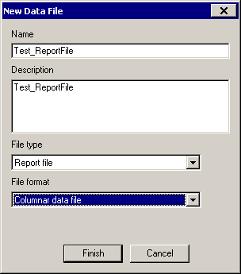

Basic Tab:
In the Basic tab we have give the location of the file which we need to use for mapping

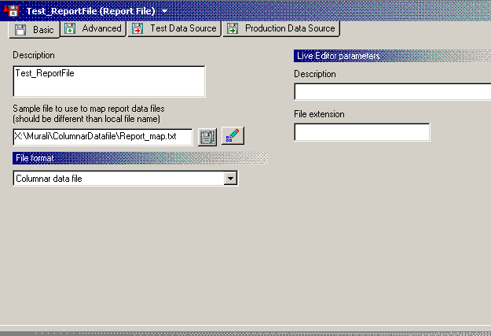

Advanced Tab:
In Advanced Tab we can control triggering the report file by selecting the option from IO Time drop down. We can also specify the targeting Rule to trigger the report.

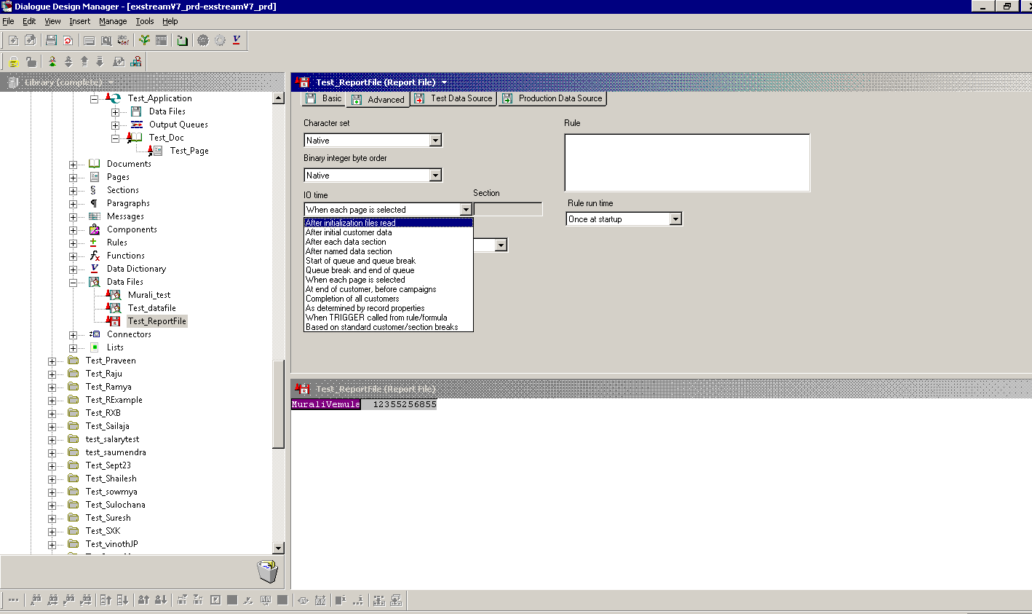
Test Data Source:

In the Test Data source tab we have to give the location of the file where the test report data output needs to be generated

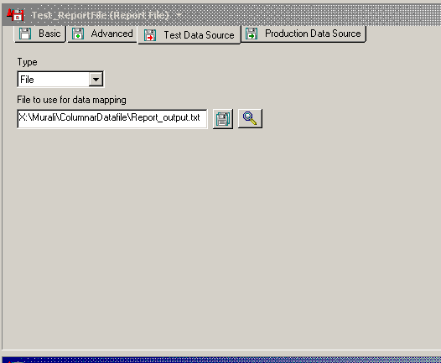

Report file mapping:
Map the report file to existing variables using test data.

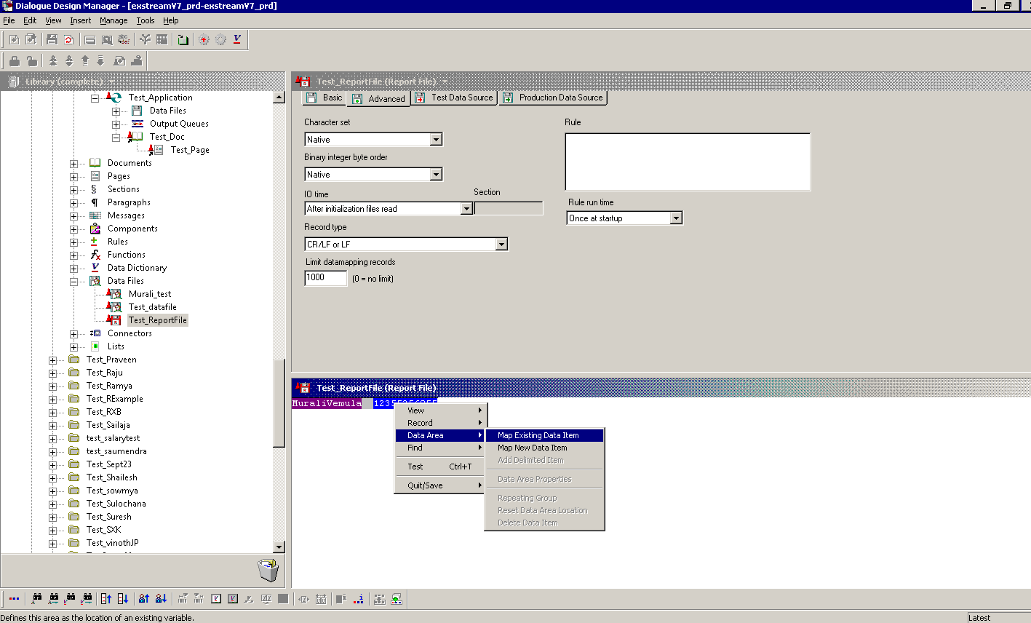

Import from COBOL Copybook file
Dialogue supports a COBOL copybook feature to significantly reduce the time needed to
create variables and map data areas. COBOL copybook enables us to import a complete
record layout into an unmapped columnar data file object and select the variables we
want to import.

- Creates variables with the same names as those in the copybook file, stored in a folder we specify.
- Maps the variables to the proper data areas.

Sample Copybook

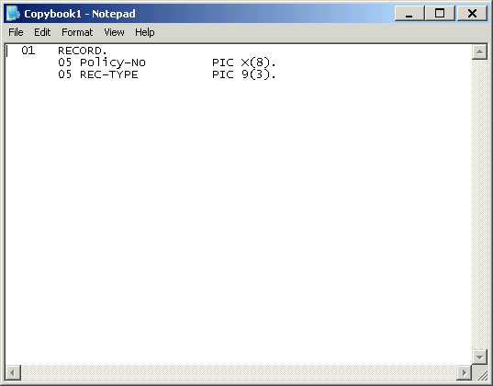

Select Copybook File:
Choose the record layout we want to import. We must import a new copybook for each record type we want to define.
To start the copybook process:
1. Drag an unmapped data file to the Edit Panel.
2. Highlight and right-click any data area.
3. Select Record -> Import From Copybook from the shortcut menu.

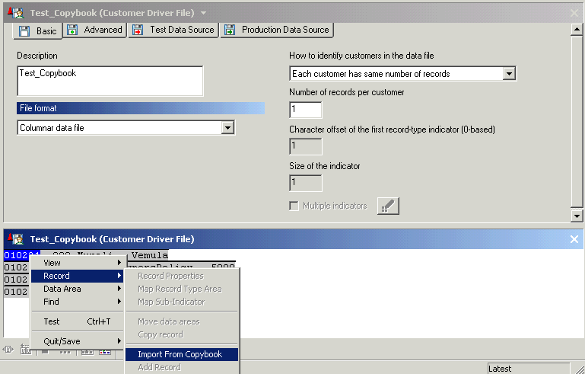

The Import from COBOL Copybook dialog box opens as shown below.

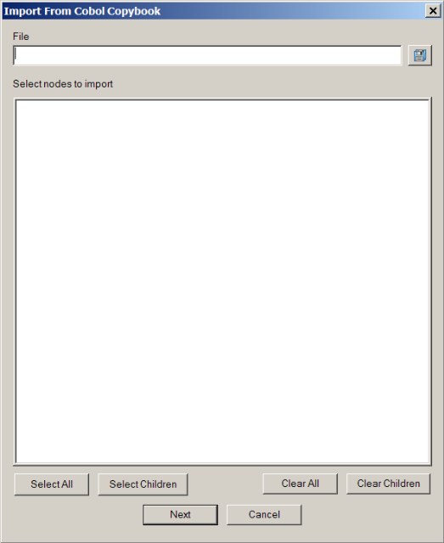

4.Type the name of the external copybook file you want to use in the File box. We can
also browse for the file by using the button.
The contents of the file appear as a tree structure in the Select nodes to import area.

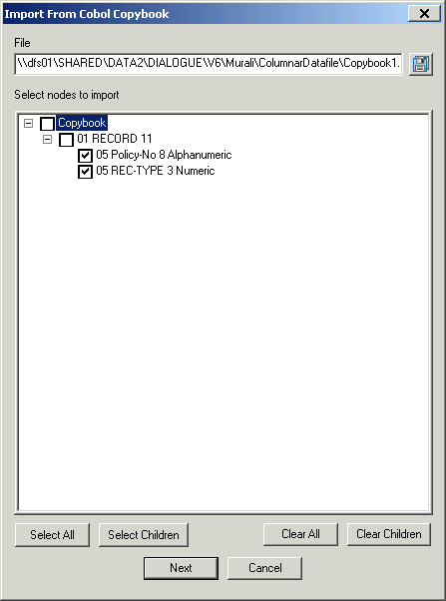

Specify variables:
Once you select the copybook file, you must specify the variables to import to the data file
object.
To specify variables:
1. Select the check box to specify the nodes (variables) needed to map the current
record. To speed this process, click the Select All or the Select Children button to
select multiple items at once. If you need to clear the options, click the Clear All or
Clear Children button.
2. Click Next.
The Copybook Import Settings dialog box opens as shown below.

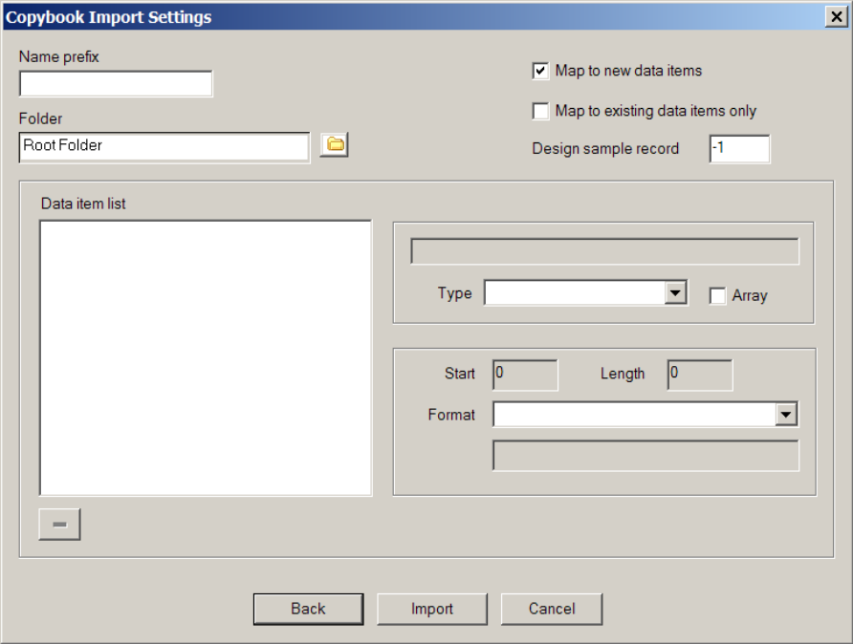

Define all the properties which you want use

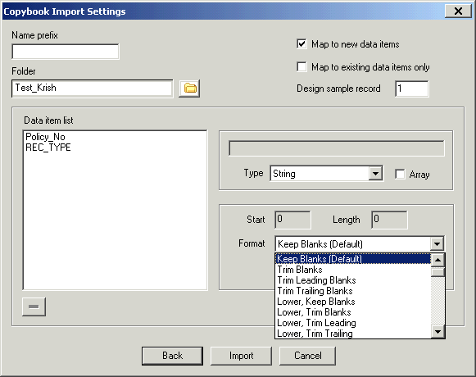

So the datafile will be mapped with the variables given in the copybook as shown below.

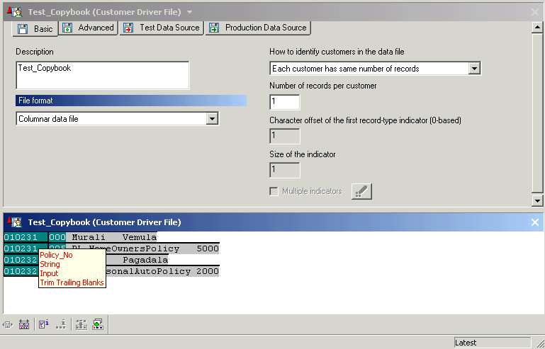

Variables
A variable is an object in the Design Manager Library that represents data that can change at Engine run-time for sources as diverse as customer data, current date and time, pages in a document or the value of other variables. These objects are located in the Variable panel and the Library under the Data Dictionary heading.

Variable Categories

System Variables
A system variable is a pre-defined variable that is standard with Dialogue software and identified by SYS_ or SYSWEB_(WebVerse). Dialogue automatically sets the values of these variables. System variables cannot be renamed or deleted.

User-defined Variables
A variable created by a Dialogue user as needed. Unlike system variables, they do not come with the software and they can be moved, deleted and renamed. These variables are not to be created in the Root Folder Data Dictionary.

Variable Types

Type | Data Referenced | Language Dependent
String | Text. | Yes
Integer | Whole numbers | No
Boolean | True or False | No
Floating | Numeric value with decimals | Yes (Formatting)
Date | Date (with or without time of day). | Yes
Currency | Monetary amount | Yes (Formatting)
Tagged Text | Tags specifying the formatting of imported text | No
Placeholder | Content from an external text or image file during an Engine run. This type of variable requires the Dynamic content import module. | No
- A language dependent variable is a variable that changes according to the language or locale of the customer according to rules you set.

Variable Sources
Variables can come from several sources:

Source | Definition
Constant User Value | A user-defined value
Formula | Computed using information from your database, based on the formula you define.
File-Only | The value originates in a data file only
Crossref page number | You create a cross-reference variable. Integer is the only valid data type for cross-reference variables.
Counter | The variable increases by one during the run according to a formula you create.

Viewing Variables
To view a list of available variables in Dialogue, you can use the Data Dictionary or the Variable palette.

View the Data Dictionary
Opening up the Data Dictionary or Property Panel provides you with a more descriptive display of the system and user defined variables.
- Expand the Data Dictionary Icon
- Drag the Data Dictionary heading into the Property or Edit Panel

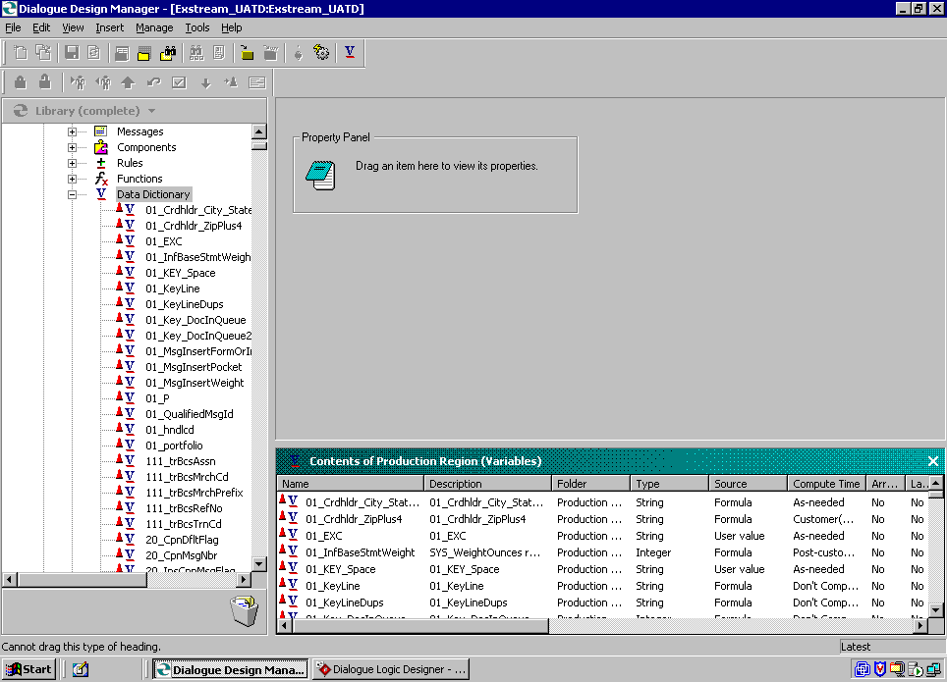

View the Variable Palette
From the View menu, select the Variable Palette.

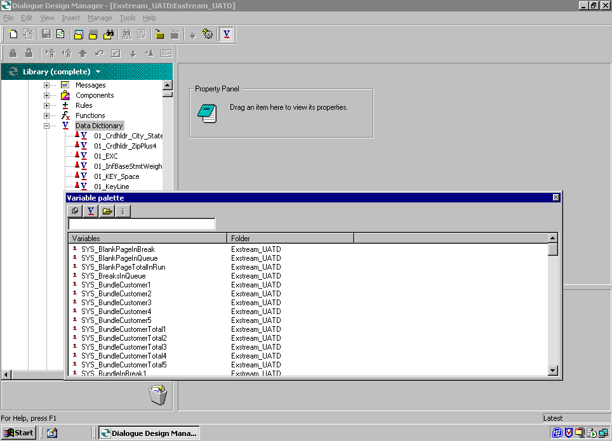

Variables - Additional Information
Additional information for data files can be found on the Terminal Server under
D:\Exstream Guides. The Guide for Data Files is Variable.pdf.

